Name: ______________________________Date: _____________

**ARTICLES OF CONFEDERATION WEBQUEST**

**Part 1:** Use the internet to provide definitions for the following terms. **KEEP THEM SHORT!!!**

|  |  |
| --- | --- |
| **Unitary** |  |
| **Confederacy** |  |
| **Federal** |  |

**Part 2: Use the provided links to answer questions 1-5.**

<http://www.congressforkids.net/Independence_articles.htm>

1. ____________________________________ wrote the Articles of Confederation during the Revolutionary War.

2. Why was the Articles of Confederation written? __________________________________________________________________ __________________________________________________________________

3. What happened after the thirteen colonies became the thirteen states? __________________________________________________________________ __________________________________________________________________

4. The Articles of Confederation became effective on __________________________________.

5. The government was ______________________ after the Articles of Confederation was put into effect.

**Part 3: Use the link provided to answer questions 6-11.**

<http://revolution.mrdonn.org/articlesofconfederation.html>

6. Name the six things that Congress could do under the Articles of Confederation:

1) _________________________________________________________

2) _________________________________________________________

3) _________________________________________________________

4) _________________________________________________________

5) _________________________________________________________

6) _________________________________________________________

7. List the 2 things that Congress could not do under the Articles of Confederation:

1) ________________________________________________________

2) ________________________________________________________

8. There was no ______________________ of the central government, and thus no separation of power at the ______________________ (central) level.

9. There was a Congress, and _________________________ states.

10. How many of the 13 states had to approve what Congress did? __________________________________________________________________ __________________________________________________________________

11. The Articles were written to govern a new country, the ______________________________________________. But the Articles were too __________________ to do that effectively.

**Part 4: Use the political cartoon provided to answer questions 12 & 13.**

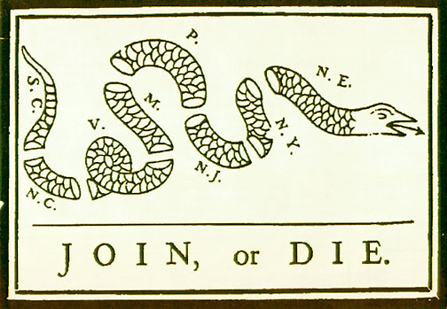

12. The Articles of Confederation call for a loose alliance between the 13 states. What does the political cartoon say about a loose alliance?

_____________________________________________

_____________________________________________

13. Based on the political cartoon, what do the 13 states need to do in order to become successful?

Part Five:

Use teachtci.com Chapter 8-Geography Challenge

1. How many of the nation's 24 largest cities and towns were located in the South?
2. After Charleston and Baltimore, how large were the South's next 4 largest cities? In which state or states were they located?
3. In what region of the nation where slaves 20 percent or more of the population?
4. Which states would most likely support a system in which the number of votes each state had in the nation's legislature was based on the state's population? Why?